RESUME

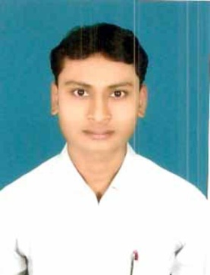
Gautam Kumar
Pursuing MBA at Gulzar Group Of Institutes, Libra, Khanna
(Punjab)

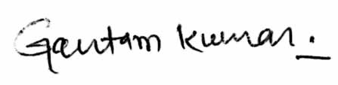
Contact No. 09955790579, 09835655274
E-Mail- gautamkumar592@gmail.com
OBJECTIVE
To be associated with a firm, this provides career development opportunities and contributes in its progress through my knowledge and skill.
EDUCATIONAL QUALIFICATION
Qualification | University/Board
Graduation(BBA) | SMU
Intermediate | B.S.E.B,( Patna)
Matric | B.S.E.B,( Patna)

Technical Qualification
Diploma in Computer Application (DCA)
Cyber Security training.
ACADMIC PROJECT AND TRAINING
Ten days project work assigned by the institute in final semester.

Languages Known : English, Hindi, Bhojpuri
Hobbies : Music, Chess

PERSONAL DETAILS
Name : Gautam Kumar
Father’s Name : Brajendra Prasad Singh
Mother’s Name : Mira Sinha
D.O.B : 18 February 1990
Nationality : Indian
Gender : Male
Marital Status : single
Permanent Address
Vill. :Ganj Sripalpur (Pachaina Bazar)
P.O. : Naya Mohammad Pur P.S. : Koelwar
Dist. : Bhojpur (Arah)
802163 (Bihar)
“I hereby declare that the above information’ are true to best knowledge”
Date …………..
Place …………..

Signature
(Gautam Kumar)

